

2)

The Ice Track system is designed to allow the admins and users of the software to: place new orders and modify existing ice cream orders; track inventory that’s on hand (both available and pending for shipping), shipped, defective or spoiled which will be stored in a database; track shipping status of items and allow the user to query the status of a shipment according specific attributes; manage trouble tickets stemming from both internal and customer facing problems. The entire system will run on a menu driven graphical user interface which allows the user to easily navigate between tasks. All processes, transactions, and queries will be executed in real time creating a seamless experience. The system will be built for use primarily with Windows 10 operating system but will also be compatible with previous Windows versions.

3)

We have developed numerous prototypes to get more familiar with Ruby and web development. Prototypes such as: setting up a server on a local network; practicing functions to write and read from databases; following tutorials to have a login system; basic HTML designing so not everything is in plain text. Prototypes were done on a “as they come” system where developers would Google examples and test it for our specific scenario.

4)

* 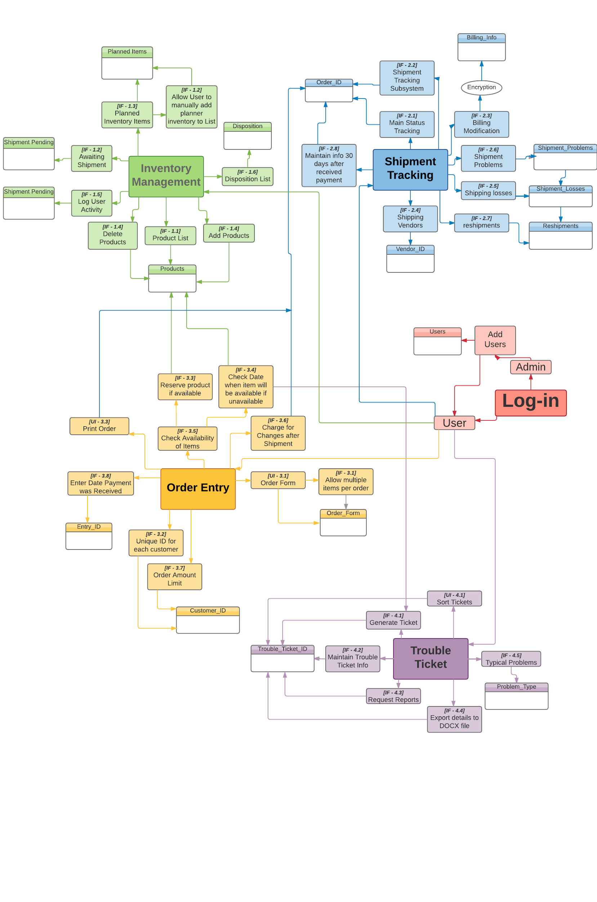
* 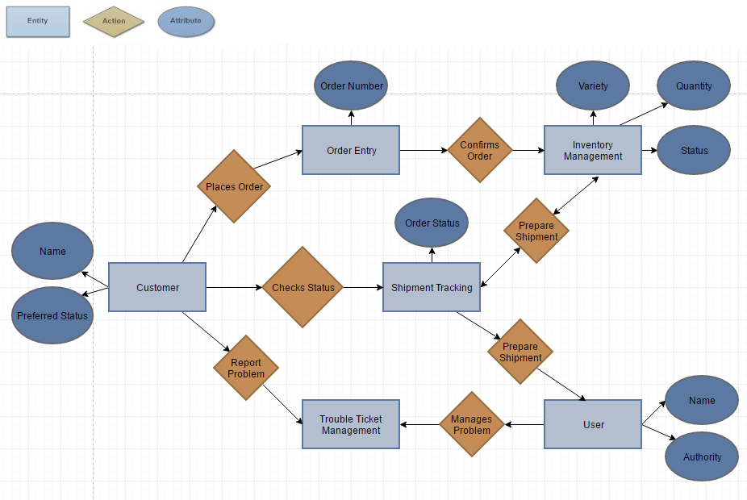

5)

Estimates:

The estimation method used will remain the same, we are using Application point sizing. We estimate to have 20 screens, 2 reports and 25 3GL components. For testing, SLOC have been chosen to be the method.

Defects:

I – Requirements:

1- The user has the possibility to create multiple accounts during the registration process due to the multi-tabs function that the user is allowed to open.

2- There is no recovery system if the wrong item is deleted or modified.

II – Testing:

1- There is no testing for duplicate products in the database.

2- There is no testing for duplicate accounts.

3- There is no testing if an unexpected change in a product’ information is due to a system error or a user error.